CEL 51, DCCN, Monsoon 2020

Lab 3: Learn usage of Packet Tracer

**Objectives**

* Install Packet Tracer from <https://www.ciscopods.com/install-packet-tracer-ubuntu/>
* Develop an understanding of the basic functions of Packet Tracer.
* Create/model a simple Ethernet network using two hosts and a hub.
* Observe traffic behavior on the network.
* Observer data flow of ARP broadcasts and pings.

**Step 1: Create a logical network diagram with two PCs and a hub**

The bottom left-hand corner of the Packet Tracer screen displays eight icons that represent device categories or groups, such as Routers, Switches, or End Devices.

Moving the cursor over the device categories will show the name of the category in the box. To select a device, first select the device category. Once the device category is selected, the options within that category appear in the box next to the category listings. Select the device option that is required.

1. Select **End Devices** from the options in the bottom left-hand corner. Drag and drop two generic PCs onto your design area.

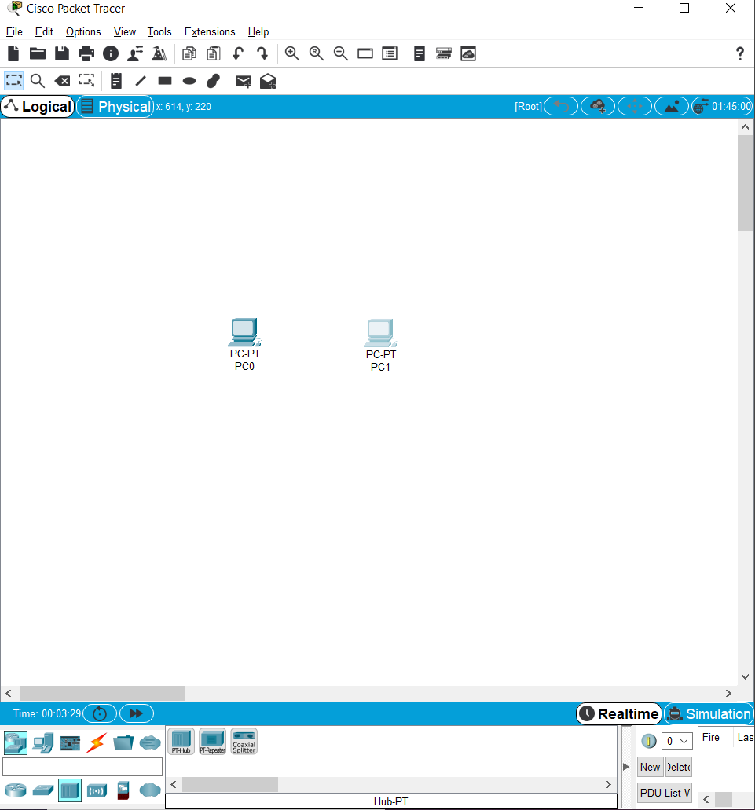

Fig 3.1 – Two PCs added to the design area

1. Select **Hubs** from the options in the bottom left-hand corner. Add a hub to the prototype network by dragging and dropping a generic hub onto the design area.

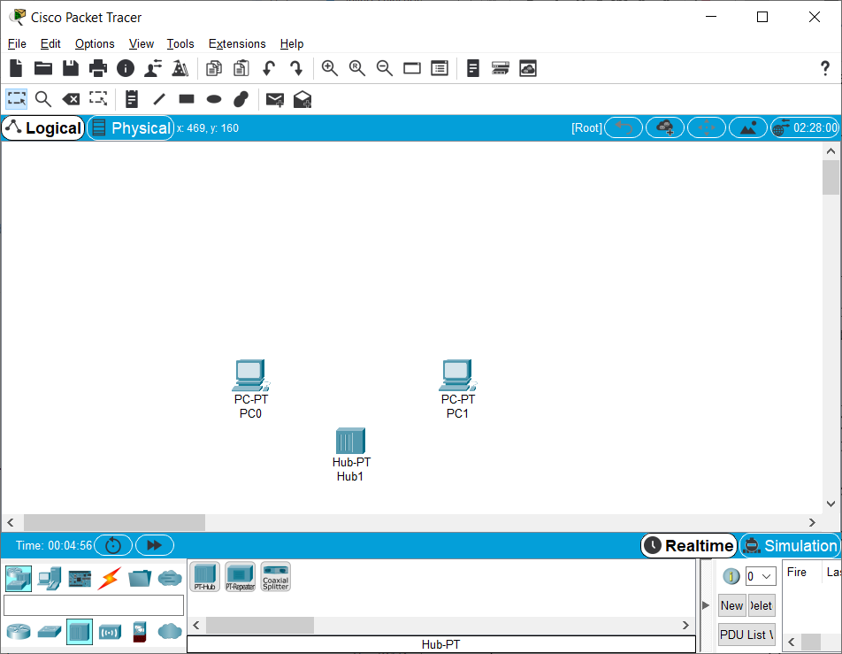

Fig 3.2 – A Hub added along with the two PCs

1. Select **Connections** from the bottom left-hand corner. Choose a **Copper Straight-through** cable type. Click the first host, **PC0**, and assign the cable to the **FastEthernet** connector. Click the hub, **Hub0**, and select a connection port, **Port 0**, to connect to **PC0**.
2. Repeat Step c for the second PC, **PC1**, to connect the PC to **Port 1** on the hub.

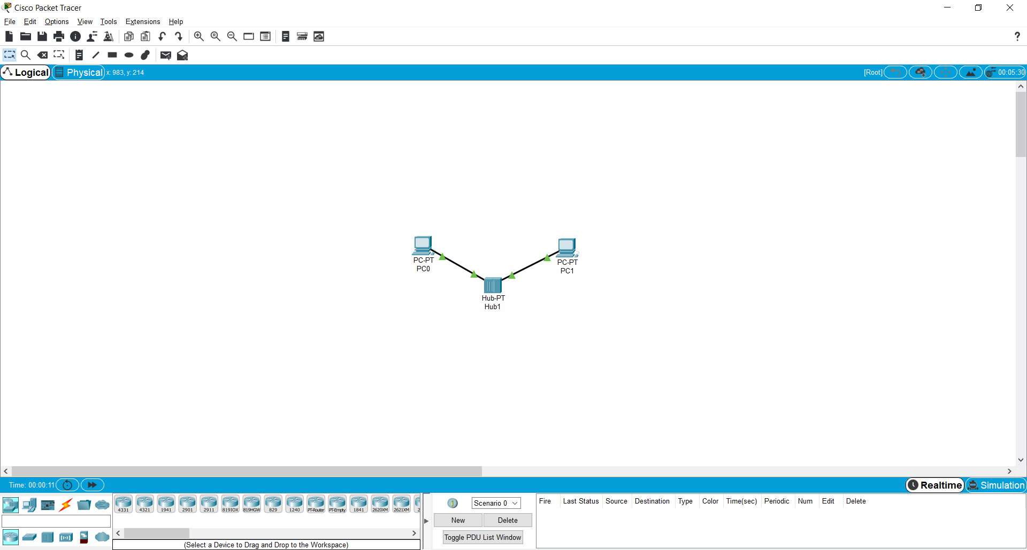

Fig 3.3 – The Two PCs and Hub are connected to each other using Fast Ethernet

*There should be green dots at both ends of each cable connection. If not, check the cable type selected.

**Step 2: Configure host names and IP addresses on the PCs**

1. Click PC0. A PC0 window will appear.
2. From the PC0 window, select the **Config** tab. Change the PC **Display Name** to **PC-A**. (An error message window will appear warning that changing the device name may affect scoring of the activity. Ignore this error message.) Select the **FastEthernet** tab on the left and add the IP address of **192.168.1.1** and subnet mask of **255.255.255.0**. Close the PC-A configuration window by selecting the **x** in the upper righthand corner.

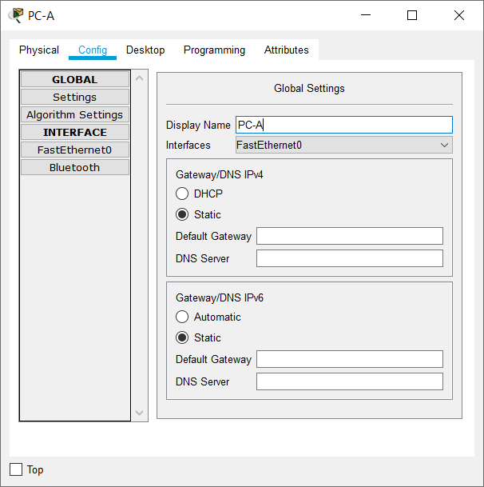

Fig 3.4 – The window for PC0 where its name has been changed to PC-A

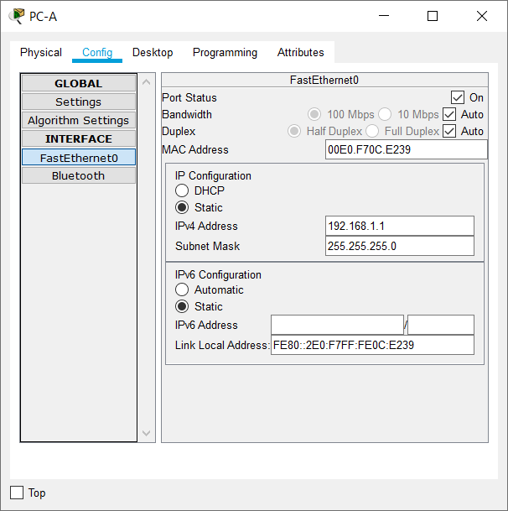

Fig 3.5 – Added the IP Address and Subnet Mask for PC-A

1. Click PC1.
2. Select the **Config** tab. Change the PC **Display Name** to **PC-B**. Select the **FastEthernet** tab on the left and add the IP address of **192.168.1.2** and subnet mask of **255.255.255.0**. Close the PC-B configuration window.

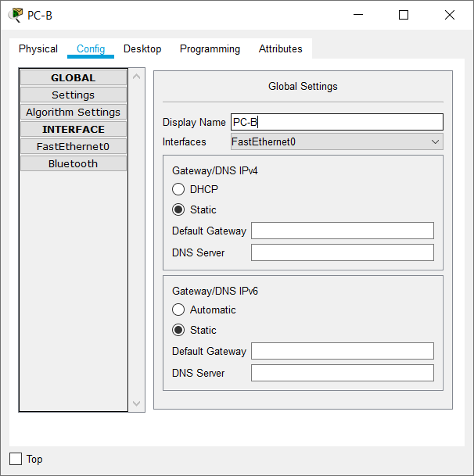

Fig 3.6 – The window for PC1 where its name has been changed to PC-B

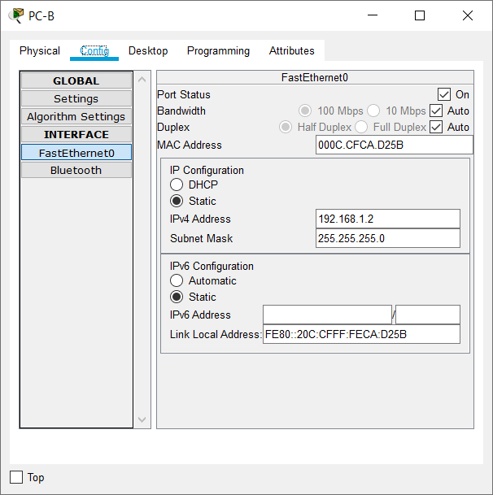

Fig 3.7 - Added the IP Address and Subnet Mask for PC-B

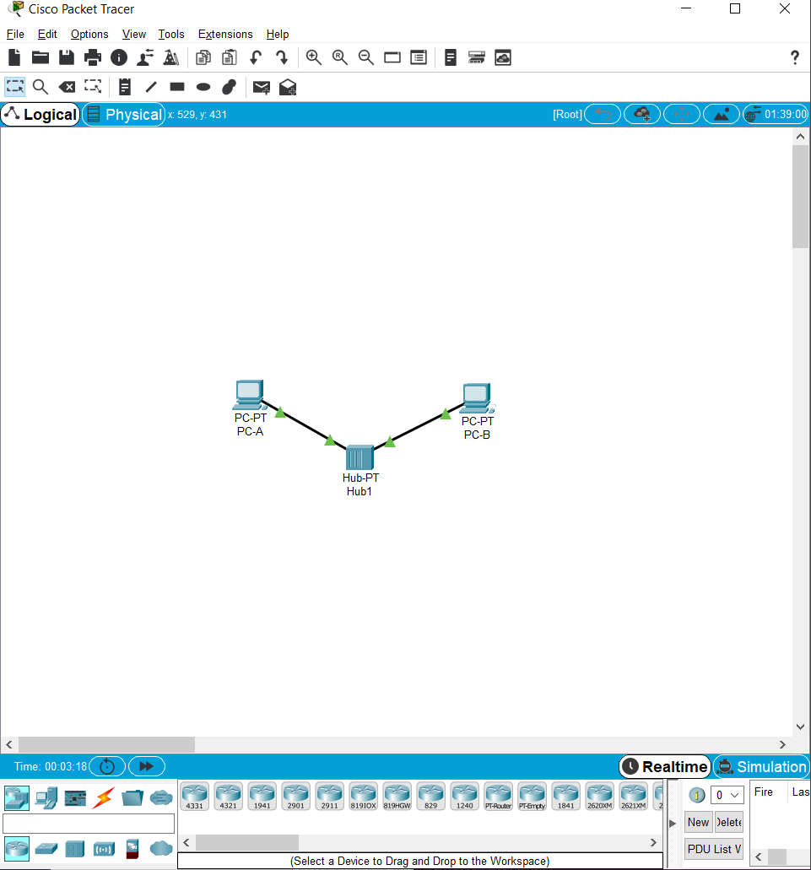

Fig 3.8 – The design area is updated to reflect the new names of PC0 and PC1

**Step 3: Observe the flow of data from PC-A to PC-B by creating network traffic**

1. Switch to **Simulation** mode by selecting the tab that is partially hidden behind the **Realtime** tab in the bottom right-hand corner. The tab has the icon of a stopwatch on it.
2. Click the **Edit Filters** button in the **Edit List Filters** area. Clicking the **Edit Filters** button will create a pop-up window. In the pop-up window, click the **Show All/None** box to deselect every filter. Select just the **ARP** and **ICMP** filters.

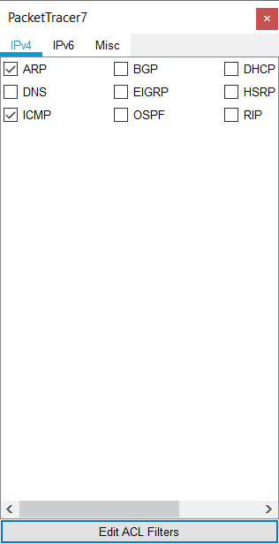

Fig 3.9 – The Edit Filters window where only ARP and ICMP have been selected

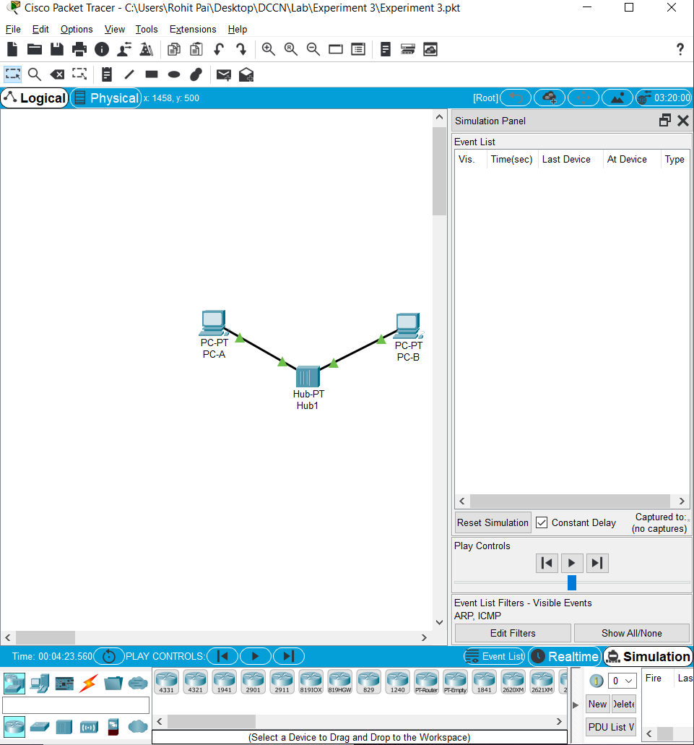

Fig 3.10 – The simulation panel is shown where we can see that ARP and ICMP are the only filters

1. Select a **Simple PDU** by clicking the closed envelope on the right vertical toolbar. Move your cursor to the display area of your screen. Click **PC-A** to establish the source. Move your cursor to **PC-B** and click to establish the destination.

**Notice that two envelopes are now positioned beside PC-A. One envelope is ICMP, while the other is ARP. The Event List in the Simulation Panel will identify exactly which envelope represents ICMP and which represents ARP.

1. Select **Auto Capture / Play** from the **Play Controls** area of the Simulation Panel. Below the **Auto Capture / Play** button is a horizontal bar, with a vertical button that controls the speed of the simulation. Dragging the button to the right will speed up the simulation, while dragging is to the left will slow down the simulation.

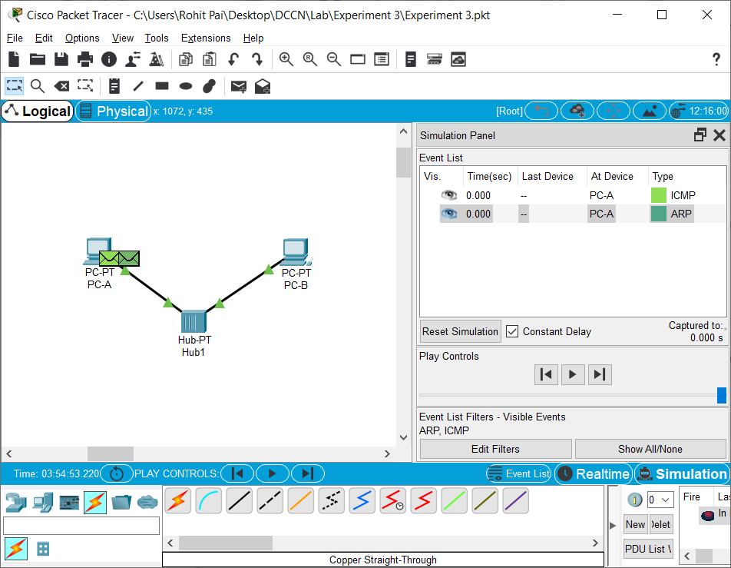

Fig 3.11 – This figure shows that the ARP and ICMP Packets have been assigned to PC-A

1. The animation will run until the message window *No More Events* appears. All requested events have been completed. Select OK to close the message box.

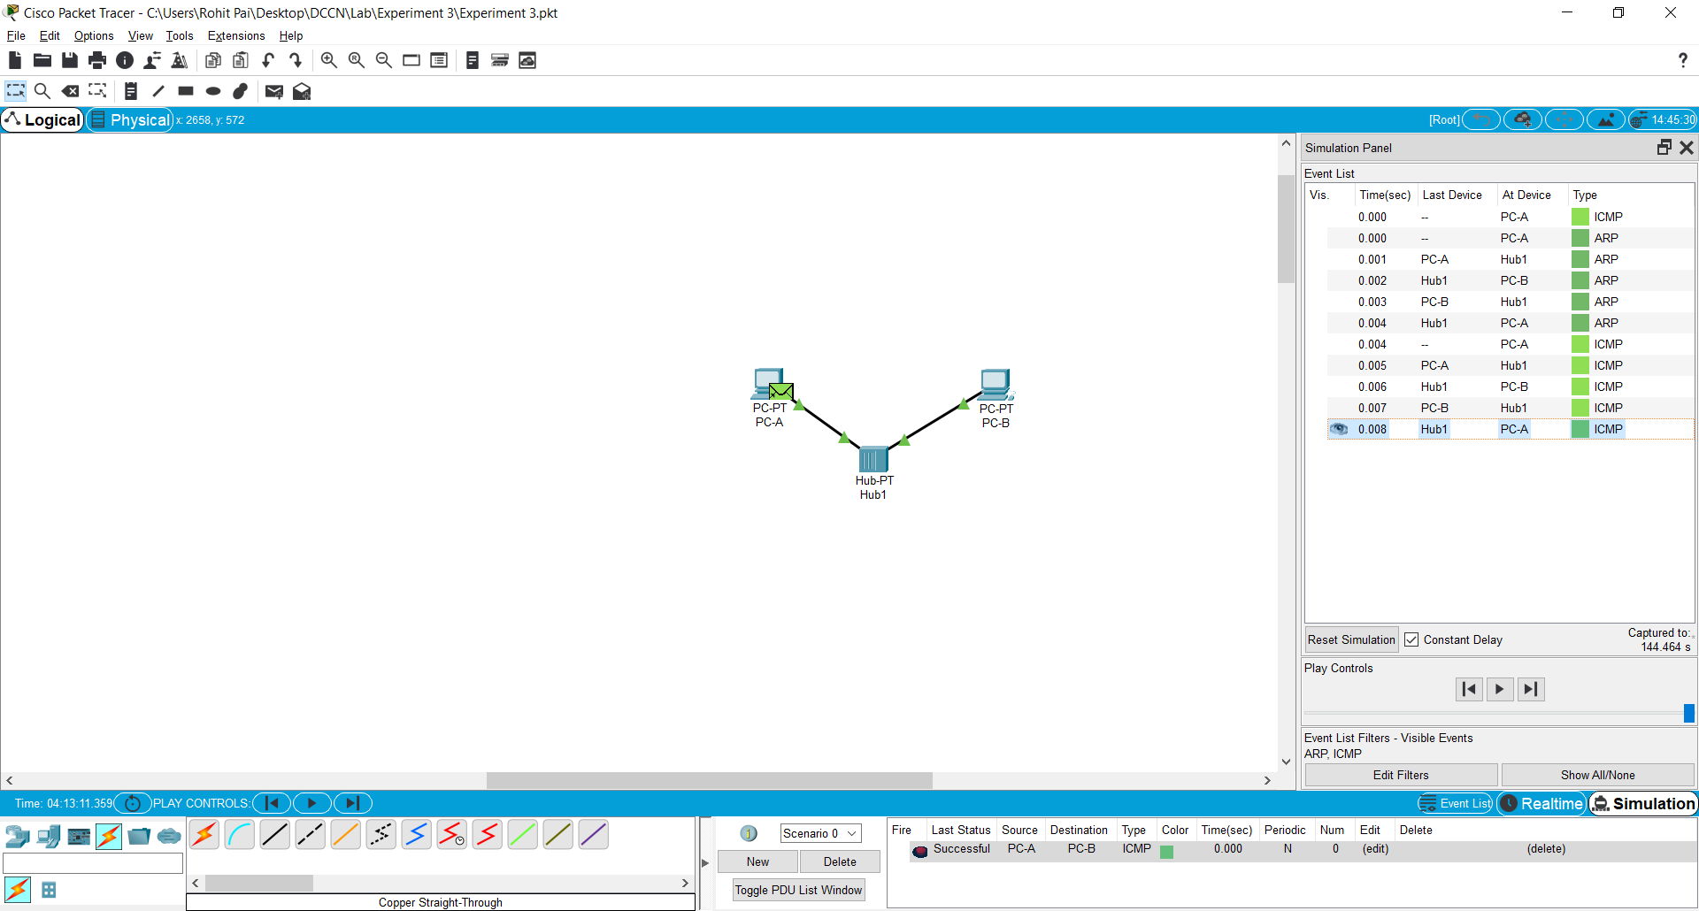

Fig 3.12 – The simulation panel shows the flow of packet between PC-A and PC-B via the hub.

1. Choose the **Reset Simulation** button in the Simulation Panel. Notice that the ARP envelope is no longer present. This has reset the simulation but has not cleared any configuration changes or dynamic table entries, such as ARP table entries. The ARP request is not necessary to complete the **ping** command because PC-A already has the MAC address in the ARP table.

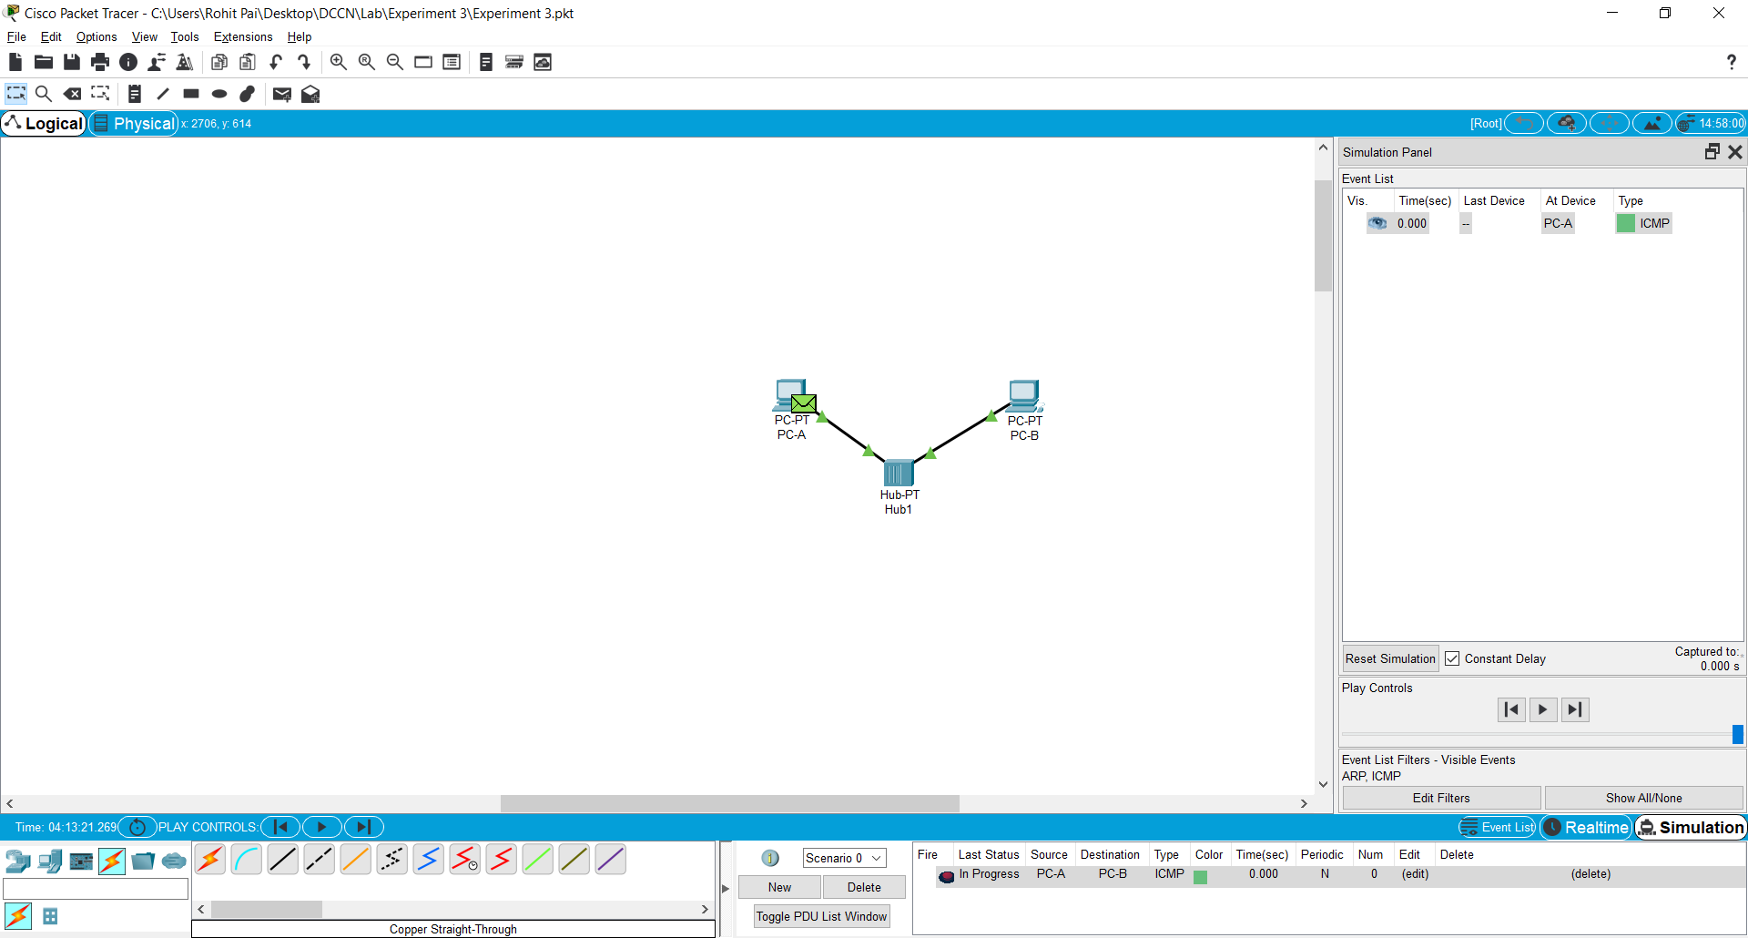

Fig 3.13 – After resetting the simulation, The ARP envelope no longer appears on PC-A

1. Choose the **Capture / Forward** button. The ICMP envelope will move from the source to the hub and stop. The **Capture / Forward** button allows you to run the simulation one step at a time. Continue selecting the **Capture / Forward** button until you complete the event.

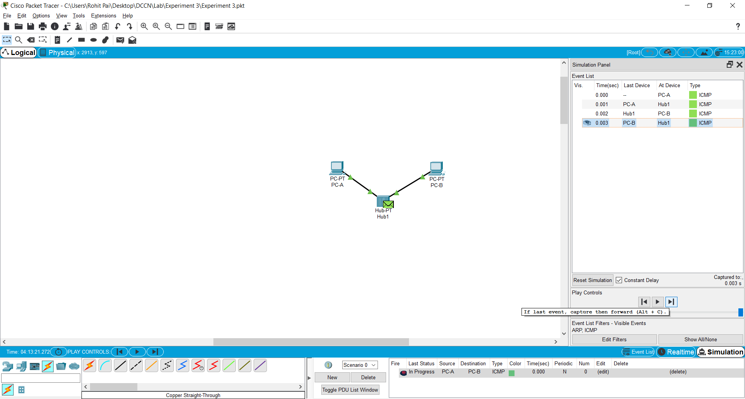

Fig 3.14 – Performing the process again by using the Forward button

1. Choose the **Power Cycle Devices** button on the bottom left, above the device icons.
2. An error message will appear asking you to confirm reset. Choose **Yes**. Now both the ICMP and ARP envelops are present again. The **Reset Network** button will clear any configuration changes not saved and will clear all dynamic table entries, such as the ARP and MAC table entries.

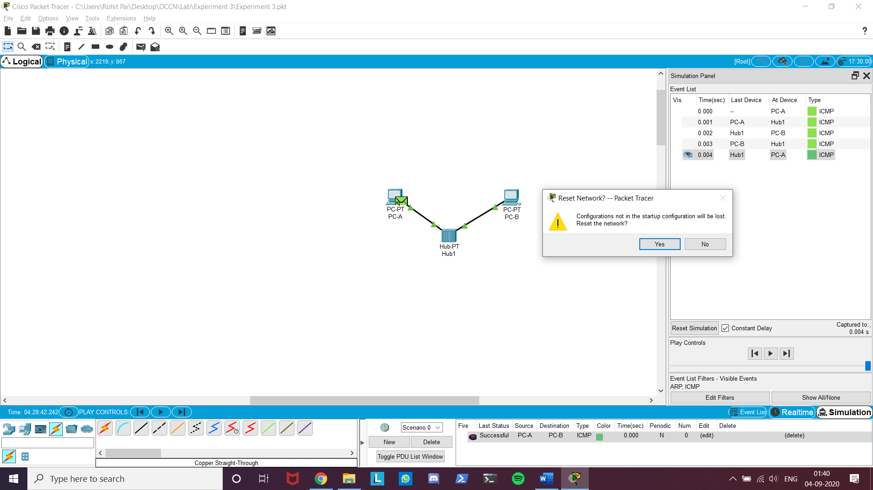

Fig 3.15 – The reset network command dialog

**Step 4: View ARP Tables on each PC**

1. Choose the **Auto Capture / Play** button to repopulate the ARP table on the PCs. Click **OK** when the *No More Events* message appears.

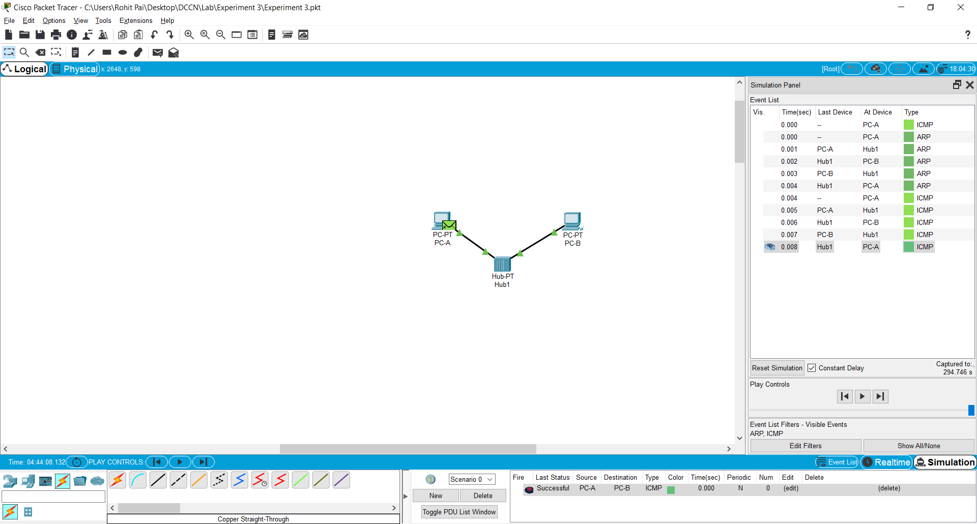

Fig 3.16 – Repopulating the ARP Tables by clicking on the Play button

1. Select the magnifying glass on the right vertical tool bar.
2. Click **PC-A**. The ARP table for PC-A will appear. Notice that PC-A does have an ARP entry for PC-C. View the ARP tables for PC-B and PC-C as well. Close all ARP table windows.

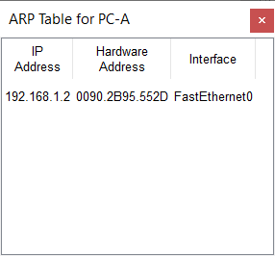 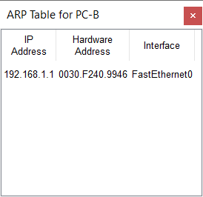

Fig 3.17 – Shows the ARP Tables for PC-A and PC-B respectively

1. Click the **Select Tool** on the right vertical tool bar. (This is the first icon present in the toolbar.)
2. Click **PC-A** and select the **Desktop** tab.

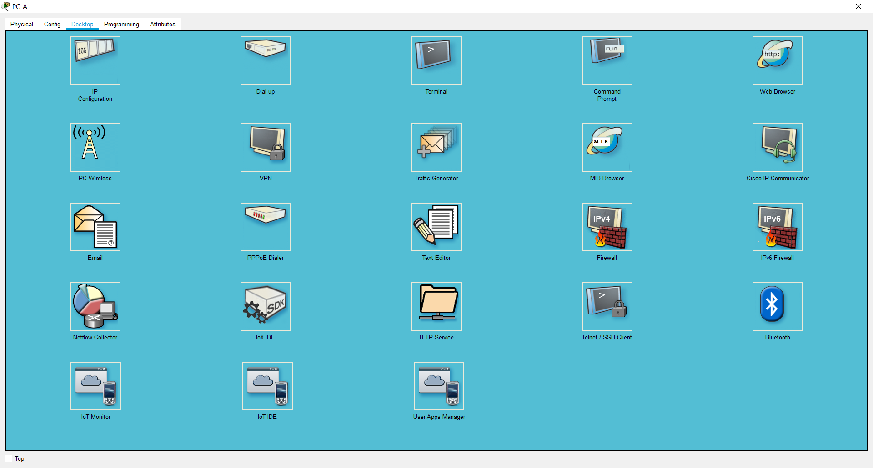

Fig 3.18 – Shows the desktop tab for PC

1. Select the **Command Prompt** and type the command **arp -a** and press *enter* to view the ARP table from the desktop view. Close the PC-A configuration window.

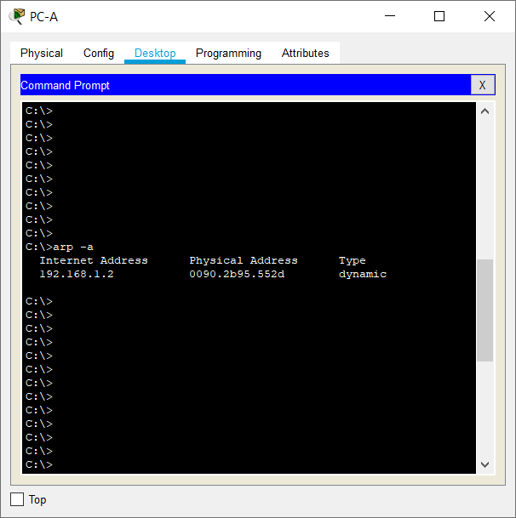

Fig 3.19 – Shows the output of **arp -a** command for PC-A

1. Examine the ARP table for **PC-B**.

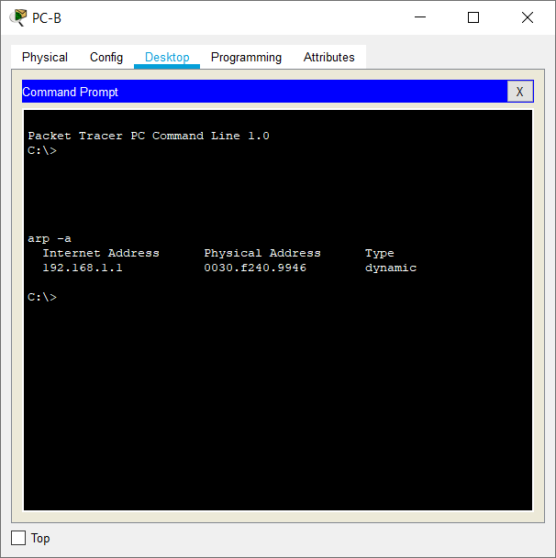

Fig 3.20 – Shows the output of **arp -a** command for PC-B

1. Close the PC-B configuration window.
2. Click the **Check Results** button at the bottom of the instruction window to verify that the topology is correct.

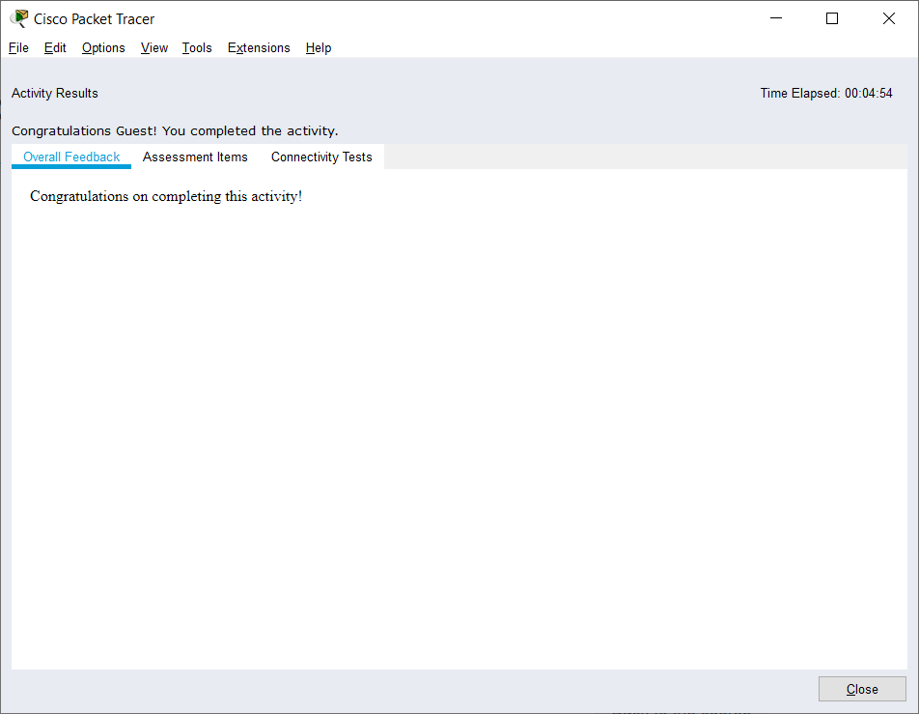

Fig 3.21 – Check results screen

**Deliverables:**

Submit model schematic view along proper notations and the outcome of all steps you followed for this experiment, with proper description.